**Data Structure-Lab File**

**Name: Janak Pandey**

**Rollno: 24/SCA/BCA/066**

**Section: BCA IIB**

1.inserting elements in the array

#include <stdio.h>

int main() {

int arr[5];

int n ;

printf(" enter the elements of array \n");

for(int i=0; i<5; i++){

scanf("%d",&arr[i]);

}

return 0;

}

OUTPUT:

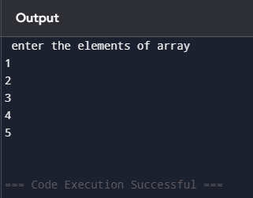

2.Searching element in array:

#include <stdio.h>

int main() {

int arr[5];

int n,count=0 , loc, upd;

printf(" enter the elements of array \n");

for(int i=0; i<5; i++){

scanf("%d",&arr[i]);

}

printf("enter the element you want to find\n");

scanf("%d",&n);

for(int i=0; i<5; i++){

if(arr[i] == n){

printf("%d found at location %d\n",n,i+1);

count +=1;

}

}

if(count == 0){

printf("%d not founded\n", n);

}

OUTPUT:

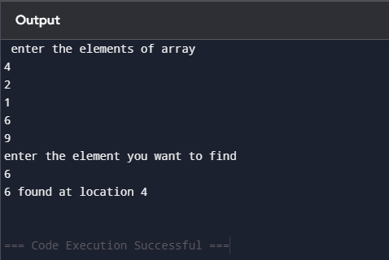

3.updating elements in array:

#include <stdio.h>

int main() {

int arr[5];

int n,count=0 , loc, upd;

printf(" enter the elements of array \n");

for(int i=0; i<5; i++){

scanf("%d",&arr[i]);

}

printf("enter the element you want to update\n");

scanf("%d",&upd);

printf("enter the location\n");

scanf("%d",&loc);

arr[loc-1] = upd;

printf("the updated array is\n");

for(int i=0; i<5; i++){

printf("%d\t",arr[i]);

}

return 0;

}

OUTPUT:

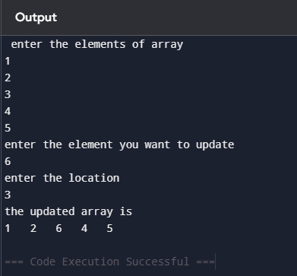

4.input a element and check wheather it is present in array or not.if the element is present in array then print the position of element.

#include <stdio.h>

int main() {

int arr[5] = {1,2,3,4,5};

int n,count=0;

printf("enter the elements to search\n");

scanf("%d",&n);

for(int i=0; i<5; i++){

if(arr[i] == n){

printf("%d is present in the %d position", n,i+1);

count +=1;

}

}

if (count ==0){

printf("%d is not present in the array\n",n);

}

return 0;

}

OUTPUT:

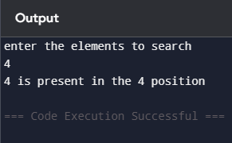

5. sorting of element in array

#include <stdio.h>

int main() {

int arr[7];

printf(" enter seven elements \n");

for(int i=0; i<7; i++){

scanf("%d",&arr[i]);

}

int temp;

for(int i=0; i<7; i++){

for(int j=0; j<6-i; j++){

if(arr[j] > arr[j+1]){

temp = arr[j];

arr[j] = arr[j+1];

arr[j+1] = temp;

}

}

}

printf("Ascending order\n");

for(int i=0; i<7; i++){

printf("%d\t",arr[i]);

}

for(int i=0; i<7; i++){

for(int j=0; j<6-i; j++){

if(arr[j] < arr[j+1]){

temp = arr[j];

arr[j] = arr[j+1];

arr[j+1] = temp;

}

}

}

printf("\nDescending order\n");

for(int i=0; i<7; i++){

printf("%d\t",arr[i]);

}

return 0;

}

Output:

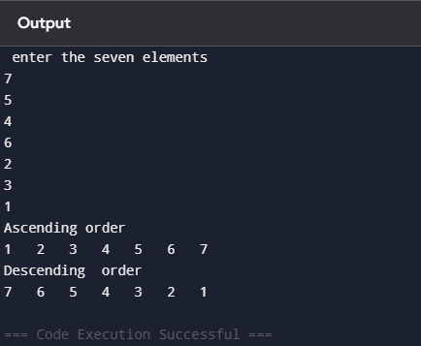

6. deletion of array

#include <stdio.h>

int main(){

int count = 0;

int x;

int arr1[] = {1,2,3,4,5};

printf("Enter the element you want to delete: \n");

scanf("%d", &x);

for(int i = 0; i<5; i++){

if(arr1[i] == x){

for(int j = i; j<5; j++){

arr1[j] = arr1[j + 1];

}

count = count + 1;

}

}

if(count == 0){

printf("Element is not found");

}

else{

for(int i = 0; i<4; i++){

printf("%d\t", arr1[i]);

}

}

}

OUTPUT:  
